Assignment 06:
- select c.car_make from car_type as c, vehicle as v where v.VIN like '%TM%'
and c.car_type_id=v.car_type_id;

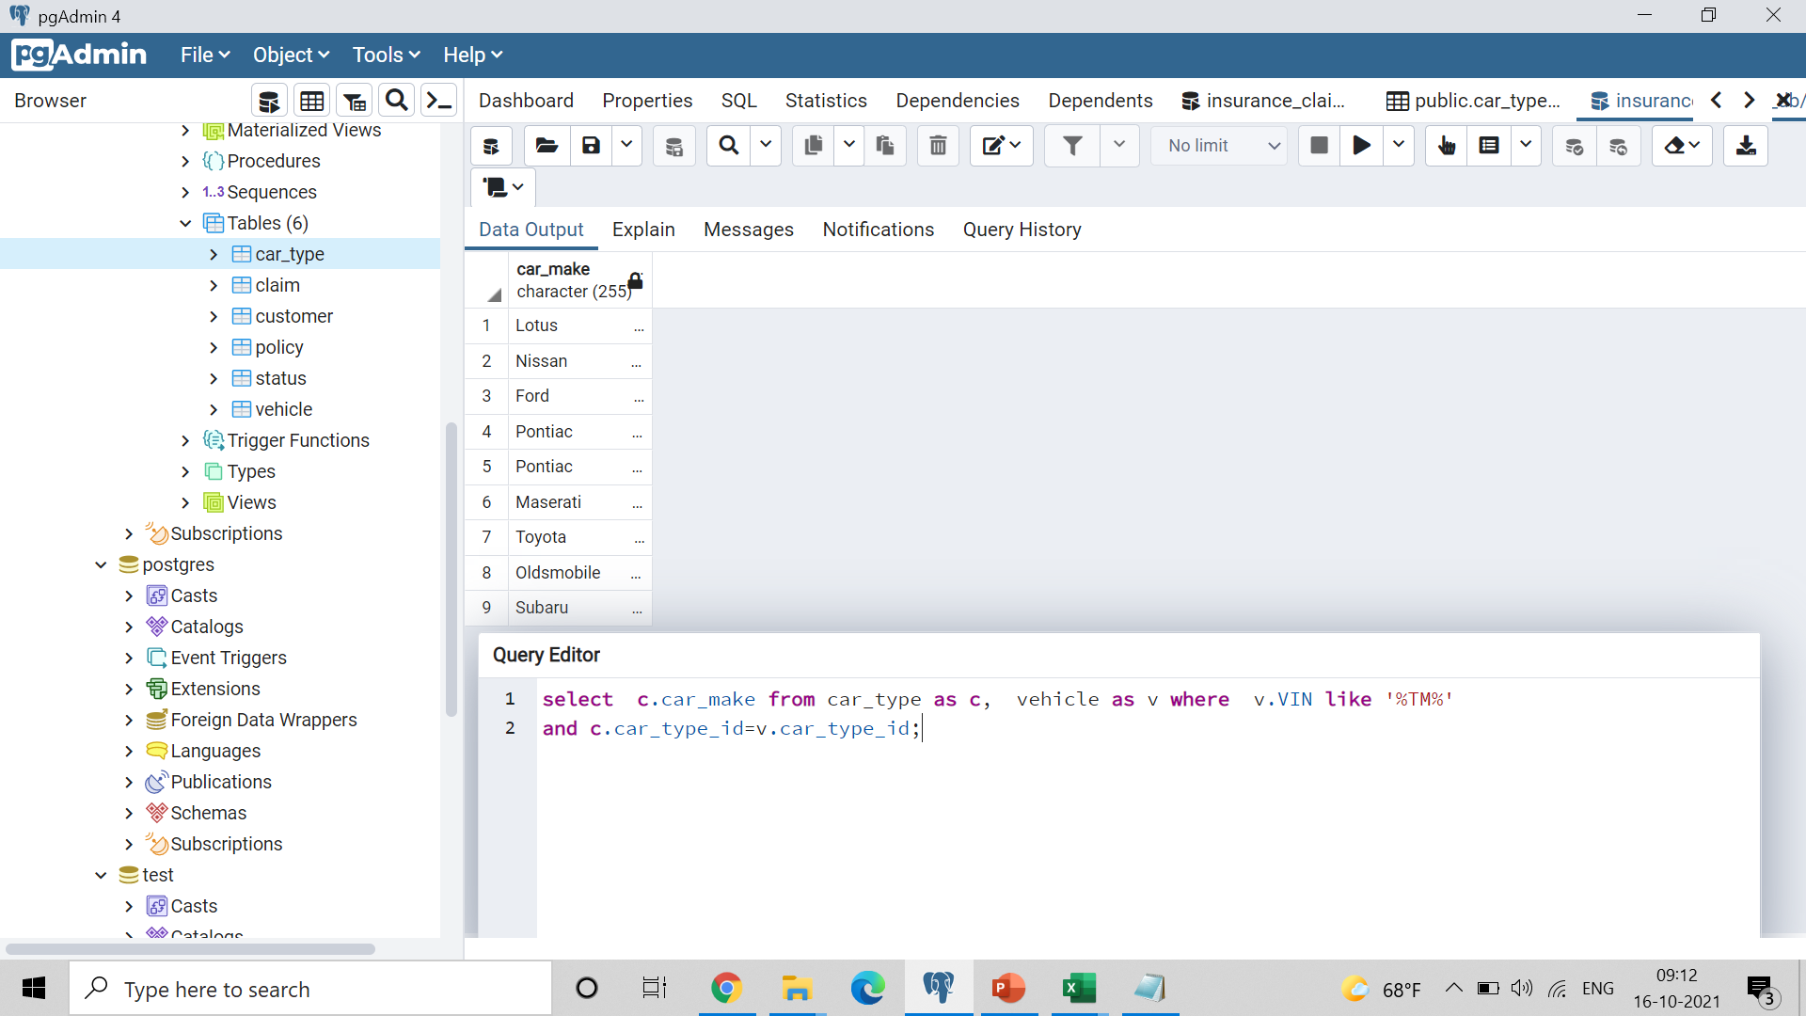

- SET car_model = 'Chevy' WHERE car_model = 'Chevrolet'; for the second part refer 2nd screenshot
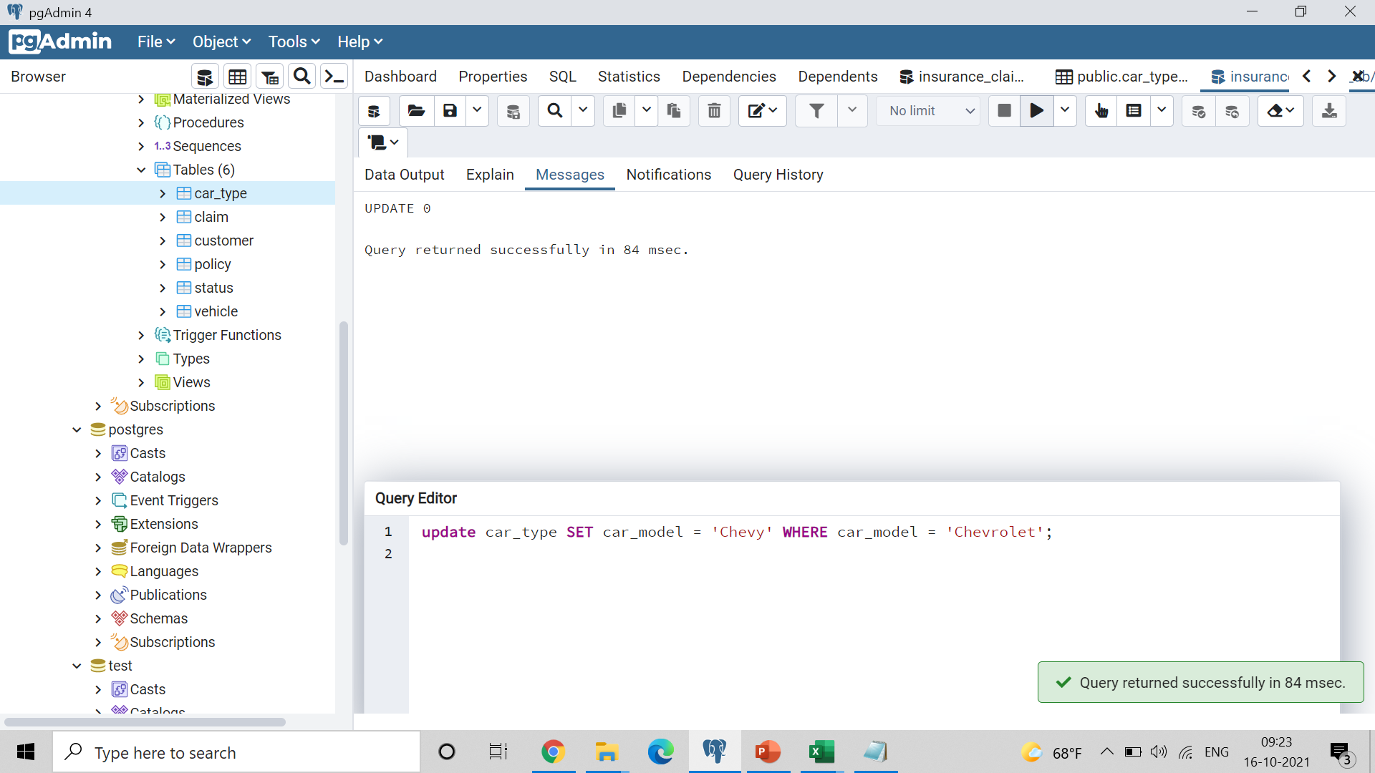

Select count(car_make) from car_type where car_make=’Chevy’;

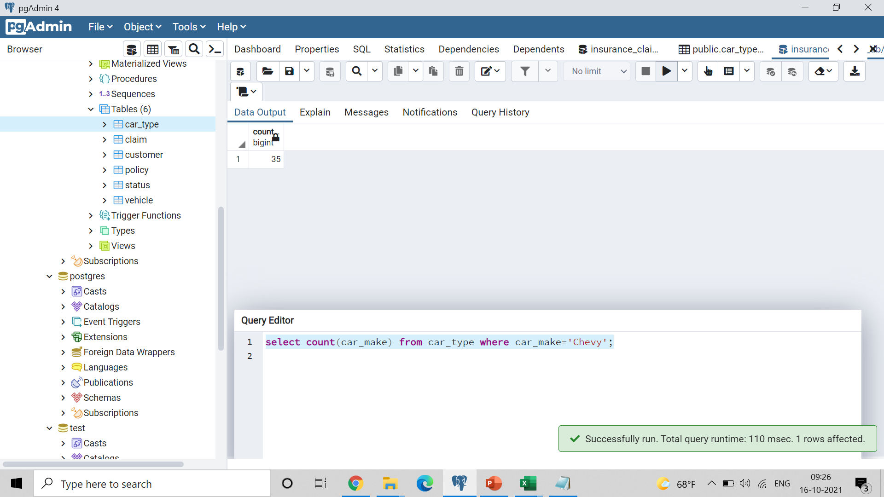

- INSERT INTO claim (claim_number,status_id,policy_number,amount,claim_date) VALUES
('565071285-9',1,'104332058-X',5000,'12/31/2018');
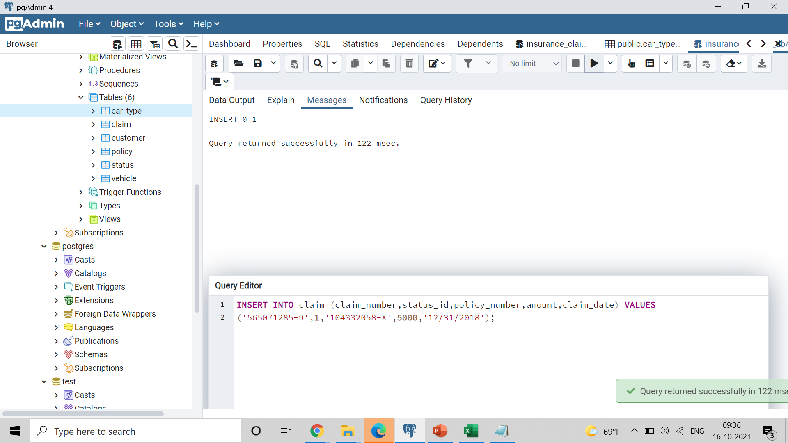

- delete from policy where vin like '%21733';
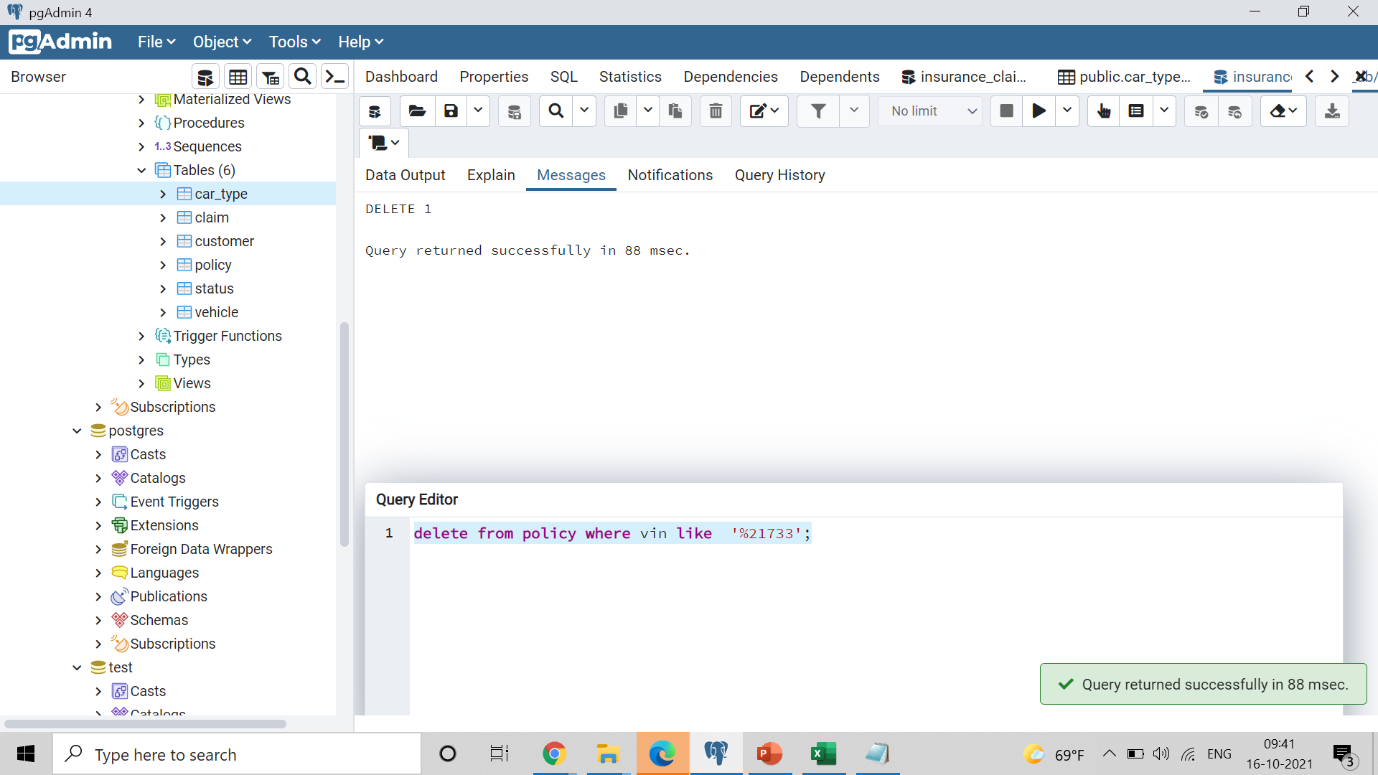

- update claim set status_id=3 from status where claim.status_id=status.status_id
and ((claim.claim_date<'2018-10-01')and status.status='denied')

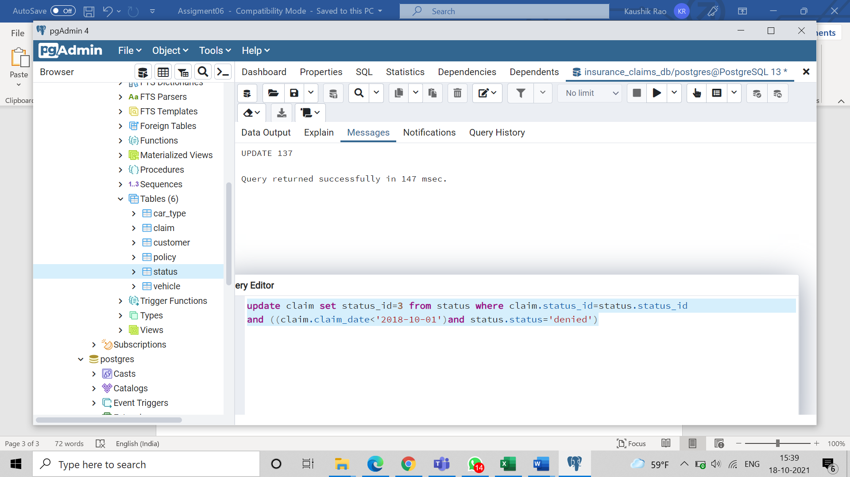

Totally 137 rows were updated

